Assignment 1:

Task:1

1. Install Jupyter notebook and run the first program and share the screenshot of the output.

x = input("Enter the welcome statement: ")

**for** i **in** x:

print(i)

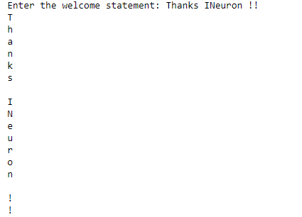



**for** i **in** range(2000,3201):

**if** i%**7** == 0 and i % 5!=0:

print(i,end=',')

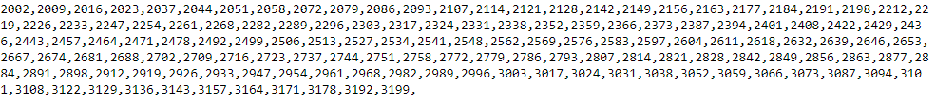



Fname = input("Enter the first name: ")

Lname = input("Enter the first name: ")

Fname = Fname[::-1]

Lname = Lname[::-1]

print(Fname,Lname,end = ' ')



4.

d= int(input("enter the diameter:"))

Vol = (4/3)*3.14*d**3

print(Vol)



**Task-2:**

**1.**

m = []

s = str(input("enter comma sertaed values:"))

l = s.split(',')

**for** i **in** l:

m.append(int(i))

print(m)



2.

**for** i **in** range(6):

**for** j **in** range(i):

print('*',end = '')

print()

**for** k **in** range(5,0,-1):

**for** l **in** range(k):

print('*',end = '')

print()

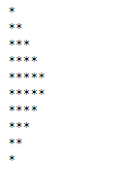

3.

alpha = input("type a word")

alpha[::-1]



4.

a = ('''WE, THE PEOPLE OF INDIA, **\n\t** having solemnly resolved to constitute India into a SOVEREIGN,! **\n\t** SOCIALIST,SECULAR,DEMOCRATIC REPUBLIC **\n\t** and to secure to all its citizens''')

print(a)

